ChemTec: Gas Leak Detection
About Gas Leak Detection

Gas escaping from pipework needs to be detected quickly. Depending on the type of gas, the consequences range from merely wasteful to fatal. Leaking gas can be environmentally damaging, it can create an explosion risk, and it can even kill thousands of people, as happened in the Bhopal chemical plant disaster. Devices like our 125 Series monitor employ a magnetic piston that floats in the gas stream. If the flow rate increases, (as happens when a leak reduces back pressure,) the piston moves higher. Sensors detect the movement and send an alarm signal when it exceeds a preset limit.
ChemTec’s Related Products: 125 Series Flow Monitor
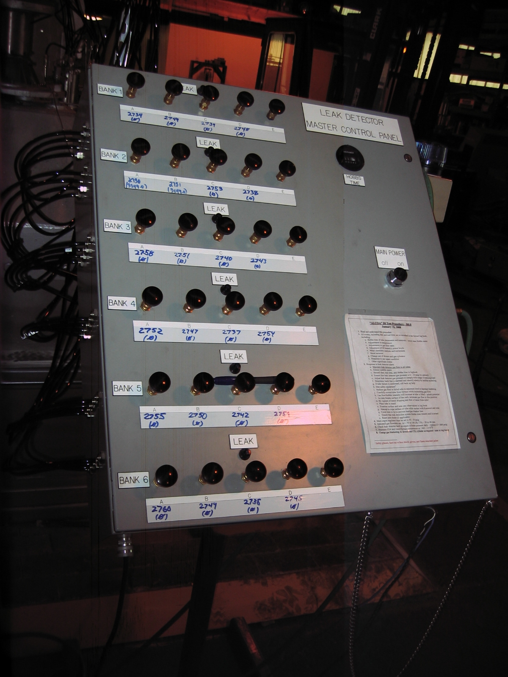
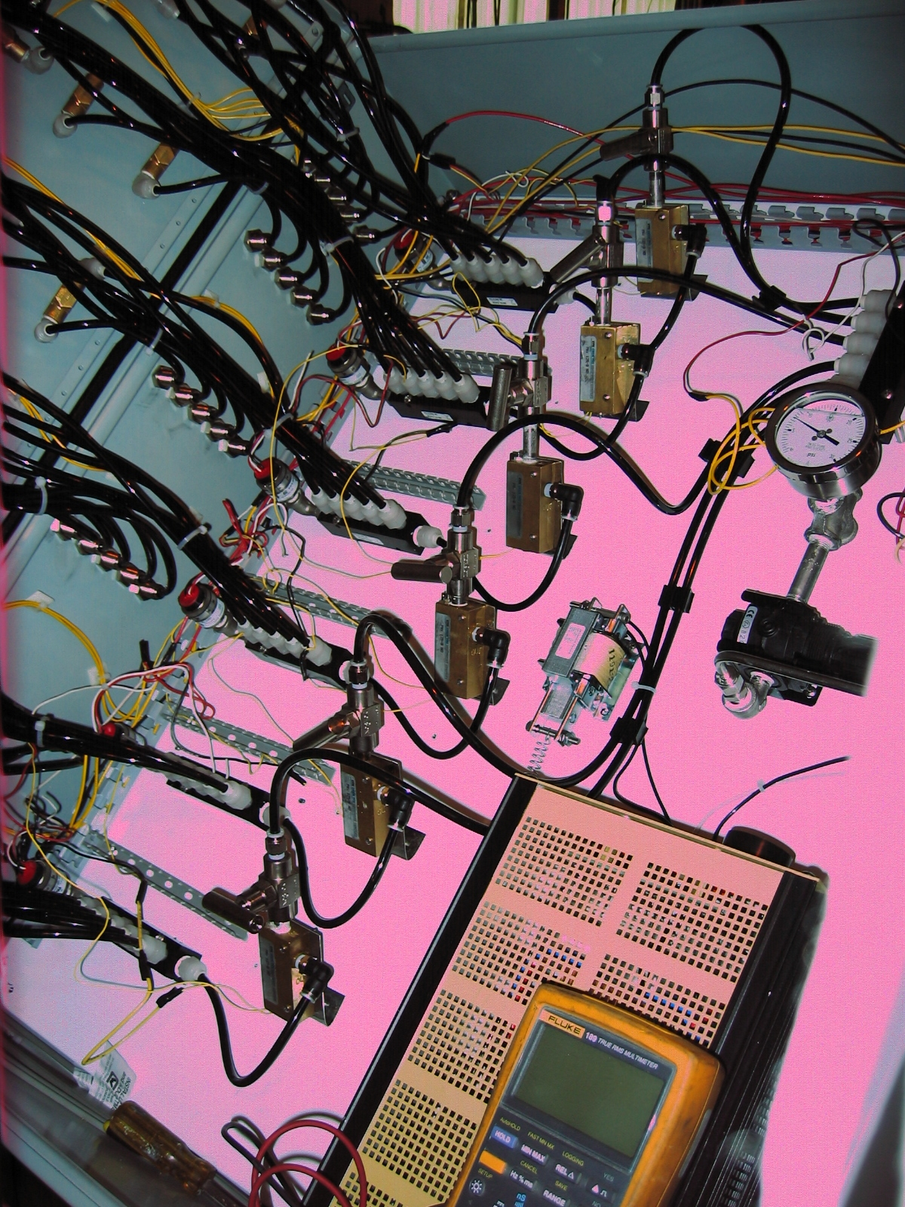
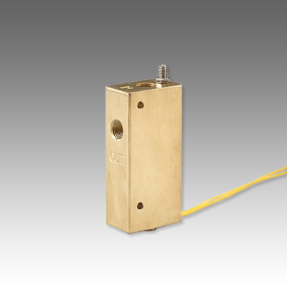

Features:
- Broad range of adjustability
- Compact Size
- High Resolution
- Materials: 316SS, Brass or Teflon
- Confirms: Normal Flow Conditions
- Output: Switch Contact
- PVC available

Applications:
- Analyzers & Welding Systems
- Purge Gases
- Wet Stations

This is the front & back on a gas leak detection panel using the 125 Series Flow Monitor.
For more information call us at 1.800.222.2177 or contact the ChemTec sales department at info@chemtec.com.

