ChemTec HPEFV: Hydrogen Fuel Cell Energy

About Hydrogen Fuel Cell Energy
Hydrogen is high in energy, yet it produces almost no pollution – making it a greener alternative! Since the 1970’s NASA has used liquid hydrogen to power their shuttles and rockets. Hydrogen fuel cells power the shuttles electrical systems, producing a clean by-product – pure water, which the shuttle crew can then use to drink. – Renewable Energy World 2013
Growth in Hydrogen Fuel Cells
As noted above, the use of hydrogen fuel cells is not new to us – but it is expected to become more popular in the upcoming years. Honda, Toyota, GM and Hyundai (to name a few) are committed to putting hydrogen-fueled fuel-cell cars on limited sale in Europe by 2015. With expected increase in hydrogen powered cars, comes the construction of hydrogen fueling stations – In the US there are currently 10 (most residing in California). Gov. Jerry Brown of California recently provided more than $2 billion in funds for clean-vehicle incentives – with a goal of 100 publicly accessible stations in next few years. – According to Green Car Report 2013
ChemTec’s High Pressure Excess Flow Valve
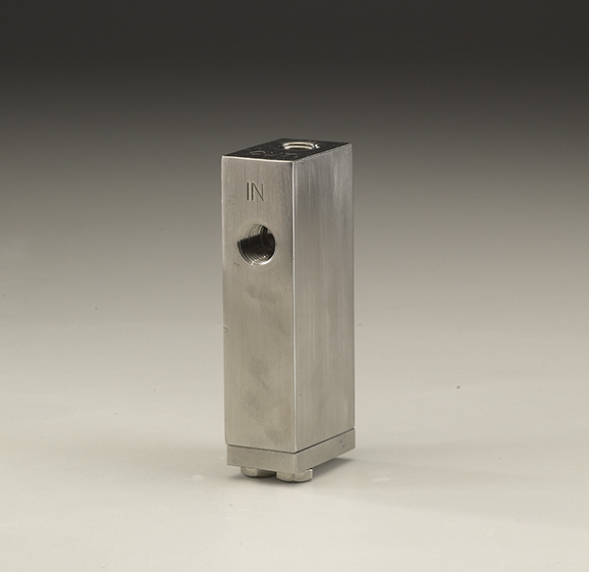
Product Features:

- Controls high pressure excessive flows
- Controlled bleed resets automatically
- Field adjustable
- Positive shut-off option
- Maximum pressure 6000 PSIG
- Detects excess flows
- Detects increase in media viscosity
- Function: Restricts or shuts off flow

How HPEFV is Used for Hydrogen Fuel Cell Energy
- If broken line, ChemTec’s High Pressure Excess Flow Valve would prevent continuous flow of hydrogen.

- ChemTec’s High Pressure Excess Flow Valve features an auto shutdown, so if pressure in the line changes the HPEFV will shutdown automatically to prevent hydrogen from escaping into the atmosphere.
For more information call us at 1.800.222.2177 or contact the ChemTec sales department at info@chemtec.com.

