ChemTec: Hydraulics

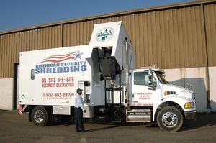
Hydraulic Technology: Shredding Trucks
When it comes to the waste industry, efficiency is a priority. With hydraulics, speed is proportional to flow, and torque is proportional to pressure, so you can easily control torque and speed by regulating pressure and flow. To remain efficient, owners and operators of trucks with hydraulics should be aware of common hydraulic problems like cavitation, aeration and overpressurization.
Industry Growth
Taking paper waste to an offsite shredding facility can be inconvenient and expensive. Mobile paper shredding trucks offer a way to insure the security of important shredding documents. Mobile shredders are contracted by high-volume paper consuming facilities like banks, hospitals and schools to dispose of sensitive files and information on site. With paper fraud accounting for 25% of reported data breaches for the first half of 2009, mobile shredders provide a quick answer to a critical but otherwise tedious at-home ritual. –Identity Theft Resource Center 2009
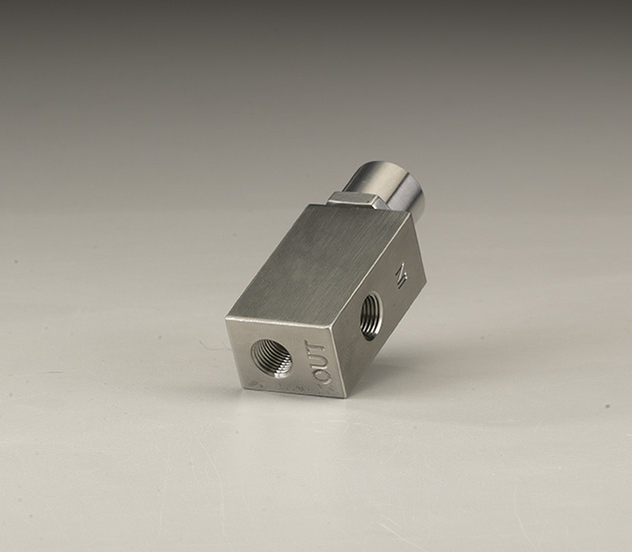
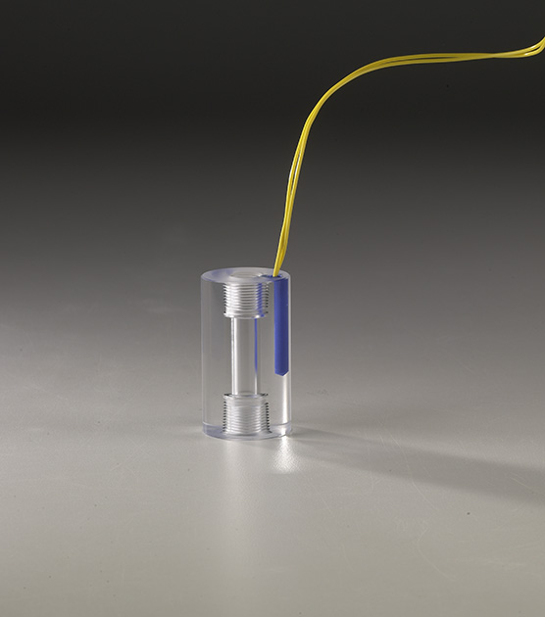
Related ChemTec Products

For more information call us at 1.800.222.2177 or contact the ChemTec sales department at info@chemtec.com.

- Attitude variable mounting
- Function: Restricts or Shuts off flow
- Output: Switch contact optional

- Controls excessive flows
- Controlled bleed, Resets automatically
- Field adjustable
- Positive shut-off
- Materials: 316ss or Brass body

- Materials: Acrylic, Brass, 316ss or Teflon

EFV Series
- Compact size
- Most economical
- Close on/off differential

LPH Series

