ChemTec EFV: Compressed Natural Gas Applications
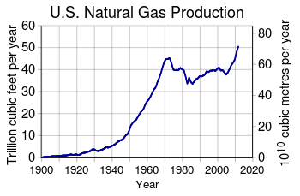
Importance & Growth
CNG is believed to be the most important energy source for the future. The abundance of natural gas coupled with it’s environmental soundness means that it will continue to play an increasingly important role in meeting demand for energy in the US.
Safety Concerns
The EIA believes the consumption of CNG will increase 65% in 2040.
- At present, 2.5 million miles of existing natural gas pipelines exist in the US.
- Compressed Natural Gas explosions can be caused by numerous factors, below are a few:
- Gas leak
- Digging near existing pipelines
- High amounts of pressure
ChemTec’s Excess Flow Valve
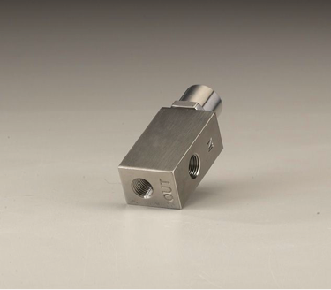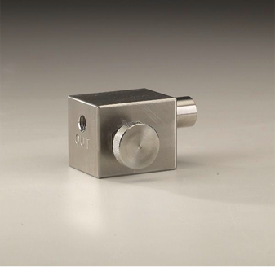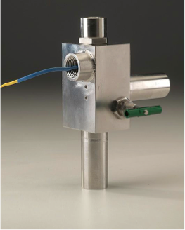
EFV Series EFV MRS Series Custom EFV Series HPEFV Series
Product Features:

- Positive shut off with internal reset mechanism
- Field adjustable
- Resets manually
- Materials: 316ss or Brass body standard
- Detects excess flows
- Detects increase in viscosity of media
- Function: Shuts off flow

- Output: Switch contact (optional)

How EFV is Used for Compressed Natural Gas
- Presently, ChemTec’s Excess Flow valves are in use at CNG filling stations and housed within NGVs and hydrogen generators

- ChemTec’s EFV monitors the flow of gas and shuts off the line if there is an Excess Flow– this helps prevent explosions!

- The EFV can also track and regulate the flow of natural gas through pipes

